DATE:25.08.2025

EXPERIMENT – 08 Create a Virtual Hard Disk and allocate the storage using virtual box.

Aim:

To create a Virtual Hard Disk (VHD) and allocate storage for a Virtual Machine using VirtualBox.

Procedure:

1. Open VirtualBox:  
   Launch Oracle VirtualBox on your host machine.
2. Create / Select VM:
   * If you are creating a new VM → click New.
   * If you already have a VM → select it and go to Settings → Storage.
3. Create Virtual Hard Disk:
   * In the VM creation wizard, choose Create a virtual hard disk now.
   * Select disk type:
     + VDI (VirtualBox Disk Image) – default format.
     + (Other options: VHD, VMDK).
4. Allocate Storage:
   * Choose Dynamically allocated (grows as you use) OR Fixed size (reserves full space immediately).
   * Enter storage size (e.g., 15 GB).
5. Attach Virtual Hard Disk:
   * The created disk will be automatically attached to the VM.
   * You can view/edit it under Settings → Storage → Controller: SATA.
6. Finalize Setup:
   * Start the VM and proceed with OS installation, which will now use the allocated virtual hard disk.

Output:

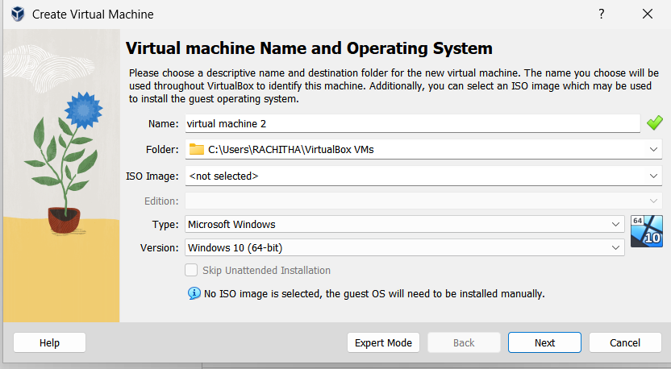

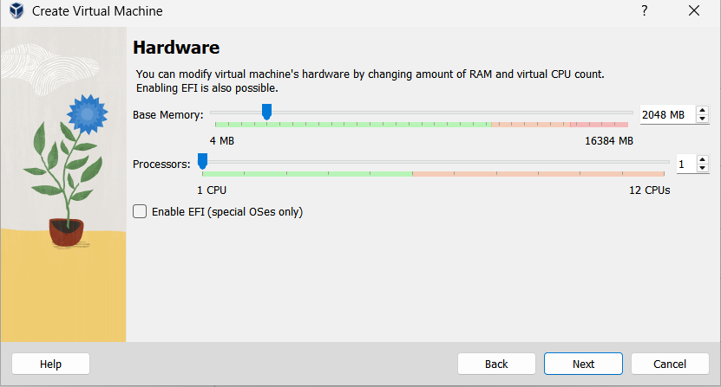

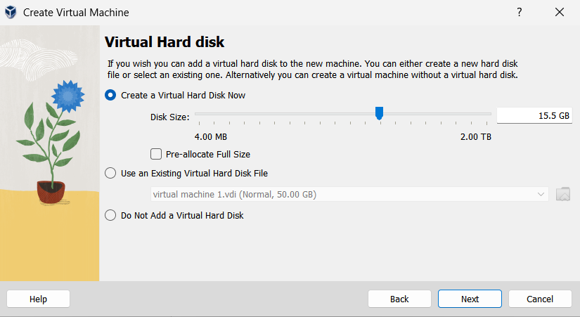

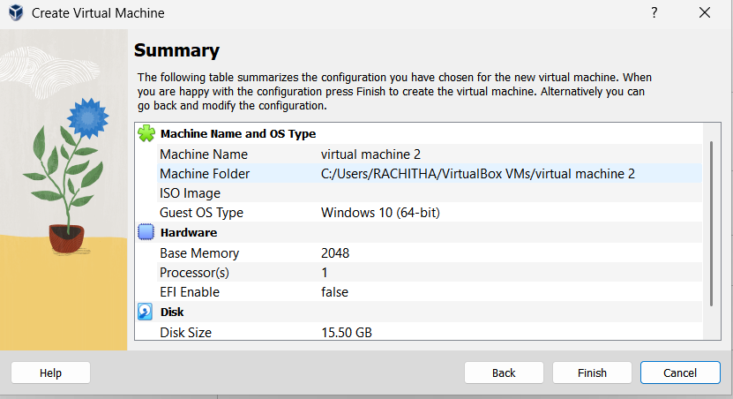

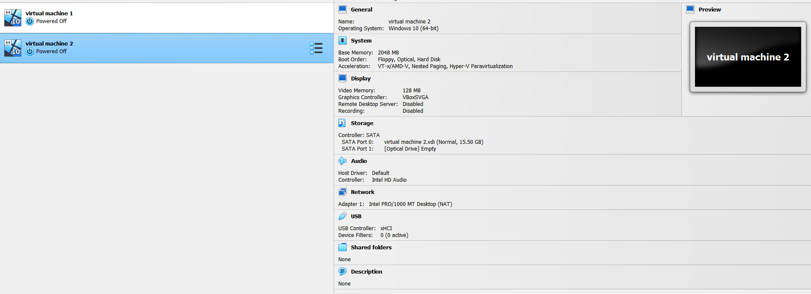

Result:

A Virtual Hard Disk was successfully created and allocated (e.g., 15GB) for use in a Virtual Machine using VirtualBox.